CASE STUDY: UK ETHNIC MINORITY EMPLOYMENT TASK FORCE

The Public Sector Scorecard was used to develop an evaluation strategy for the UK government’s ethnic minority employment task force, which was fairly unique in including government ministers from five different departments (Moullin, 2010).

The first stage was identifying the various sub-outcomes that were thought important in achieving the main desired outcome of increasing ethnic minority employment. Three separate outcomes were identified: building employability, connecting people to work, and equal opportunities.
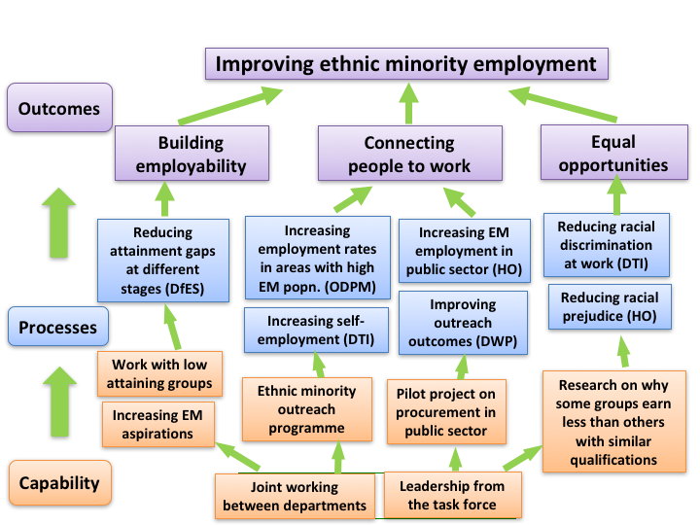

The next stage was to identify each department’s role in achieving these outcomes and how their progress could be measured. As can be seen while building employability was predominantly down to the Department for Education and Skills, the other two outcomes were the joint responsibility of a number of different government departments. The aim was to make it clear how the contribution of different departments related to the overall outcome, as well as helping in the evaluation.

A number of performance measures are also given for the different outcome elements, along with the government department responsible. In this way, each department could see which outcomes they were contributing to, how progress would be measured, and how their work fi tted in to the wider picture.

The impact of the Task Force can be seen from the graph below. The gap between ethnic minority and overall employment rates reduced from 22 percentage points to 12 – a reduction of 45% - between 2003 and 2008.

