PAPER FOR PMA SYMPOSIUM LOCH LOMOND 2013

Improving public and third sector performance with the Public Sector Scorecard

Author: Max Moullin, Director, Public Sector Scorecard Research Centre and Visiting Fellow, Sheffield Business School

Keywords: Public Sector Scorecard, Strategy Mapping; Public Sector, Balanced Scorecard

ABSTRACT

Most public and third sector organisations – both within and beyond Europe - are struggling with two major problems: improving outcomes for service users and stakeholders without increasing overall cost; and developing measures of performance that help them improve and assure quality without motivating staff to achieve arbitrary targets at the expense of poor service to the public.

As an integrated service improvement and performance management framework designed for the public and third sectors, the Public Sector Scorecard is ideally placed to help organisations address both these issues.

The paper begins by discussing a number of factors which are important in managing and measuring performance - focusing on outcomes and evidence-based drivers of outcomes; working across organisational boundaries; integrating risk management, capturing the voice of users and other stakeholders; and developing a performance management culture based on improvement, innovation and learning rather than a top-down blame culture.

Originally developed in 2001, the Public Sector Scorecard (PSS) has three phases - strategy mapping, service improvement, and measurement and evaluation. It is a workshop-based approach working with managers, staff, service users and other key stakeholders. The essence of the model is its emphasis on three elements: outcomes, processes and capability. It focuses on the outcomes that matter to service users, the processes that deliver these outcomes, and the organisation's capability to support its people and processes to achieve the relevant outcomes.

The paper illustrates, with the aid of several case studies, how the PSS has been used to help organisations improve their outcomes, including value for money, and evaluate how well they have performed.
PMA SYMPOSIUM 2013 - Loch Lomond

TITLE: Improving public and third sector performance with the Public Sector Scorecard

AUTHOR: Max Moullin, Director, Public Sector Scorecard Research Centre, Visiting Fellow, Sheffield Business School.

1. INTRODUCTION

Most public and third sector organisations – both within and beyond Europe - are struggling with two major problems: improving outcomes for service users and other key stakeholders without increasing overall cost; and developing measures of performance that help them improve and assure quality without motivating staff to achieve arbitrary targets at the expense of poor service to the public.

As an integrated service improvement and performance management framework specially designed for the public and third sectors, the Public Sector Scorecard (Moullin, 2002) is ideally placed to help organisations address both these issues.

A number of factors are important in managing and measuring performance to overcome these problems. They include working across organisational boundaries; capturing the voice of users and other stakeholders; focusing on outcomes and evidence-based drivers of outcomes; using outcomes to drive process re-design and address capability and organisational issues; integrating risk management; minimising the unintended consequences of any performance targets set; and developing a performance management culture based on improvement, innovation and learning rather than a top-down blame culture.

This paper begins by outlining the Public Sector Scorecard and how it works in practice. It then discusses a number of barriers to effective performance management and how the Public Sector Scorecard methodology aims to address them in order to help organisations deliver improved outcomes and develop a more meaningful performance management culture. Two in-depth case studies using the PSS across organisational boundaries are then presented, one in central government and the other in a major city.

2. USING THE BALANCED SCORECARD IN THE PUBLIC SECTOR

While the balanced scorecard has been used with varying degrees of success in many public sector organisations (e.g. Radnor and Lovell, 2003, Niven, 2003, Greatbanks and Tapp, 2007) its language, architecture and methodology very much reflect its private sector origins. Indeed Gambles (1999, p.24) says that ‘…in its usual form, it (the scorecard) is clearly not suitable for the vast majority of the public sector’. One of the main problems is that the most important perspective of the balanced scorecard is the financial perspective. Indeed most companies only measure non-financial factors because they recognise that they will at some point affect bottom-line financial performance (Moullin, 2002, Pidd, 2012,p.209). This is not the case in the public and voluntary sectors, where an organisation which has a large surplus at the end of the year, but has long waiting lists or poor outcomes is not a well-performing organisation.

Kaplan and Norton claim that all that needs to be done to adapt the BSC for use in public sector organisations is to 'rearrange the scorecard to place customers or constituents at the top of the hierarchy' (Kaplan and Norton, 2001b, p. 98) and several other attempts have been made to refine it for the not-for-profit sectors (e.g. Irwin, 2002, Woodward et al, 2004, Lawrie and Cobbold, 2004). However Northcott and Taulapapa (2012) conclude that although each of the eight New Zealand local government organisations they examined had modified the BSC to fit their organisations, they had all encountered significant difficulties in doing so. Similarly, reviewing the use of the balanced scorecard (BSC) within healthcare, Gurd and Gao (2008) conclude that 'current applications do not tend to show the health of patients as being central to the development of the BSC; the balance is tilted towards the financial not the health outcomes’.

Another problem is that the methodology is still private-sector oriented with little emphasis on service user involvement, risk management, or the need to work across organisational boundaries (Moullin, 2006). However rather than adapt what is essentially a private sector model to fit all sectors, an alternative approach is to design a model specifically for the public and voluntary sectors - and this is the approach taken by the Public Sector Scorecard.

3. THE PUBLIC SECTOR SCORECARD

The Public Sector Scorecard (PSS) is an integrated service improvement and performance management framework for the public and third sectors. It has three phases - strategy mapping, service improvement, and measurement and evaluation.

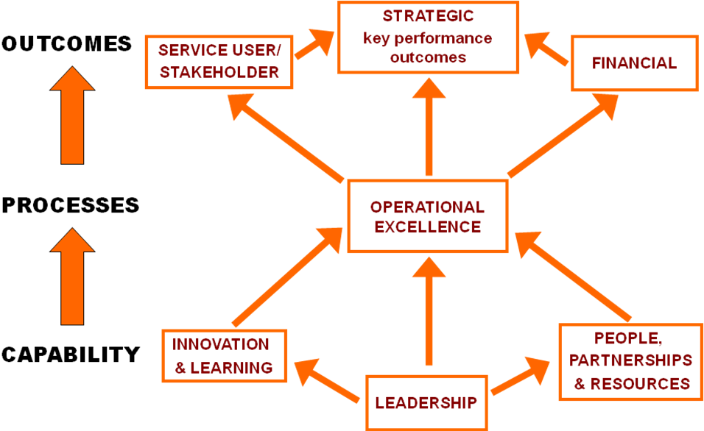

Figure 1. The Public Sector Scorecard

At the heart of the PSS is the very simple, yet powerful, model on the left hand side of figure 1. Processes lead to outcomes, while capability - defined as the organisational, cultural and resource-based factors that need to be addressed for processes to work effectively - leads to effective processes.

The right hand side of figure 1 provides more detail on the different elements. Outcomes include the key performance outcomes that the organisation aims to achieve, those required by users and other key stakeholders, together with financial outcomes such as breaking-even, securing funding, and offering value for money. There will be a variety of processes within an organisation and the PSS aims to help organisations achieve operational excellence so that they can achieve the various outcomes. Capability comprises what needs to be done to support staff and processes in delivering the outcomes required. This might include trained and motivated people, good partnership working and sufficient resources, together with a culture based on innovation and learning rather than a blame culture - all underpinned by effective and supportive leadership.

The PSS is a flexible framework and the seven perspectives can be ignored or changed according to the needs of the organisations, provided that they address outcomes, processes and capability as illustrated in the first column of Figure 1.

4. HOW THE PSS WORKS

The PSS is a workshop-based approach working with managers, staff, service users and other key stakeholders and has three phases - strategy mapping, service improvement and measurement and evaluation - see Figure 2.

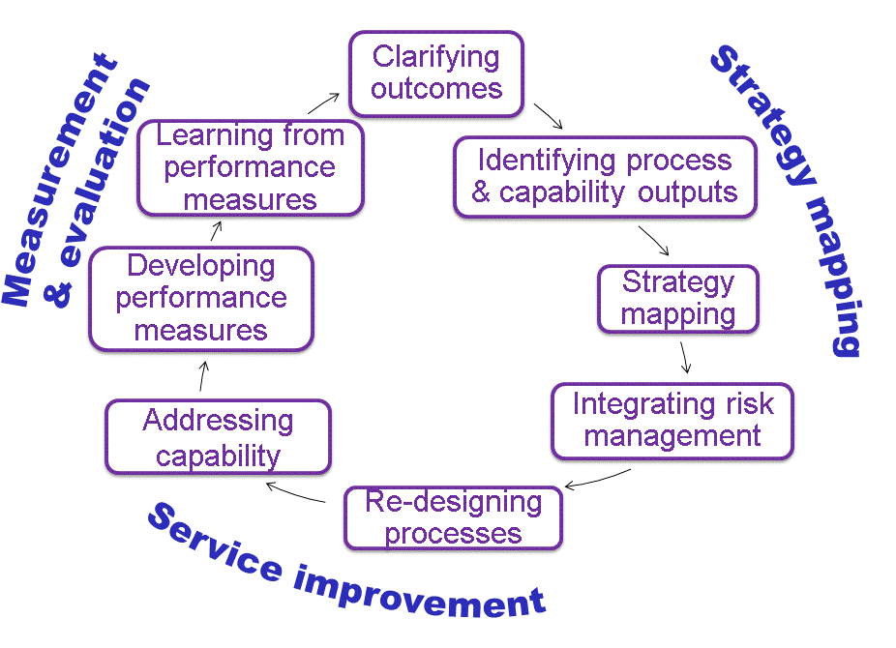
Figure 2. How the Public Sector Scorecard works

Strategy mapping

As with the balanced scorecard, the strategy map is a key output of the PSS. According to Kaplan and Norton (2001a, p11) a strategy map ‘describes how shareholder value is created from intangible assets’. However with the PSS it can be defined more simply as 'depicting the relationships between outcome, process, and capability elements' (Moullin, 2009a).

The strategy map is developed following a series of interactive workshops with senior managers, staff, service users and other stakeholders. These workshops would start by identifying the desired outcomes - strategic, service user, stakeholder and financial outcomes.

Workshop participants would then consider the outputs that the various processes involved need to achieve in order to deliver the various outcomes. Following this the group would be asked to identify the capability outputs that are needed to ensure that staff and processes are able to achieve the outcomes and process outputs required. These aspects might include effective team and partnership working, sufficient resources, supportive leadership, together with an organisational culture which promotes innovation and learning rather than a target-obsessed blame culture.

The links between capabilities, processes and outcomes are then illustrated in a draft strategy map which is then brought to the next workshop to get feedback from participants. Risk factors will then be identified in a risk management workshop and added to the draft strategy map by considering the reduction of a key risk as a desired outcome. The processes by which risks are reduced, eliminated or mitigated are then reviewed, together with the risk management culture (a capability element) and added to the strategy map.

As Pidd points out, 'there may well be some conflict between the strategic drivers (of the PSS) and any strategic thinking will need to balance differing claims and priorities' (Pidd, 2012, pp.211-212; McAdam, Hazlett and Casey, 2005).

Service improvement In this phase the strategy map will be used as a prompt to examine the effectiveness of different processes in achieving the required outcomes and how they can be improved. Workshop participants will be encouraged to link their discussion to evidence or data available and this will be supplemented where appropriate with tools such as process maps, systems thinking and lean management - for example to highlight areas of duplication, processes that could be simplified or accelerated through better communication and eliminating non-productive activities such as talking to users who ring up because they have not received a service they were promised.

This or a subsequent workshop would then focus on what is required to achieve the capability outputs in the strategy map and in particular how management can support staff and processes so that they can obtain the outcomes required. This could involve extra resources in a particular area, improving staff morale, and clear supportive leadership. It might also involve discussing how to develop a culture of improvement, innovation and learning rather than a blame culture.

Measurement and evaluation This phase begins by identifying possible performance measures for each element of the strategy map. Discussion will take place with workshop participants, with information experts within the organisation, and with stakeholders and funders on their information requirements and the likely cost-effectiveness of different measures. It is important that the measures chosen are seen as reasonable by both staff and service users

All potential measures identified will be reviewed by considering data quality issues, and aiming to minimise potential unwanted or perverse effects. A filtering process then takes place to ensure that the measures chosen are cost-effective and can provide value for money to the organisations concerned. Performance measurement has been defined as 'evaluating how well organisations are managed and the value they deliver for customers and other stakeholders' (Moullin, 2002, p. 188). This definition has a deliberate circularity - performance measurement is part of how an organisation is managed, so it too needs to deliver value to users and stakeholders.

Performance measures do not necessarily need to be quantitative. Indeed in many cases - particularly on some of the capability areas – more qualitative approaches are preferable. For example if improving partnership working is included in the strategy map, a summary of progress and people's perception on what has been achieved will be better than recording the number of meetings with different organisations or other irrelevant measures.

Analysing and learning from performance measures provides insight into how well organisations are performing in the different areas of the strategy map. The use of statistical tools to determine cause and effect where possible is also useful here. Taking action to address areas needing attention is also needed!

Completing the Cycle

Performance information is then used to revise the strategy map, identify further service improvements, and develop better performance measures - and so the cycle continues. Public and third sector organisations have frequent changes in strategy and it is important that the strategy map is a living document and that performance measures are aligned with a changing strategy (Johnston and Pongatichat, 2008).

5. KEY FEATURES OF THE PSS

The Public Sector Scorecard is designed to fit the culture and values of public and third sector organisations (Moullin, 2009, Penna, 2011). This section discusses a number of issues which are critical to its success, some of which are also applicable to private sector companies.

a. Service user and stakeholder involvement.

In contrast to the balanced scorecard which is generally implemented top down 'cascading the scorecard down the organisation' (Bourne and Bourne, 2007,pp.166-7) a key element of the PSS is its emphasis on service user and stakeholder involvement. This 'places the experiences and knowledge of the service user at the heart of effective public service design and delivery' (Osborne, Radnor and Nasi, 2013, p146).

By involving users, staff and other key stakeholders in an interactive workshop setting, it not only enables service delivery to address the needs of these stakeholders, it also leads to more successful implementation since users feel involved in the process of service improvement and the resulting changes rather than feel that change is imposed on them.

For example a project using the PSS for Sheffield's Stop Smoking Service began with three workshops with over 100 service users and was then steered by a reference group which included managers and staff of the service, eight service users, a GP, a hospital consultant and representatives of the Strategic Health Authority. The project's recommendations did not therefore come as a surprise to such stakeholders and were consequently well received (Moullin et al, 2007).

b. Focus on outcomes

Identifying the outcomes required by the organisation, its service users and other stakeholders - including value for money - is the starting point of a PSS study and this outcome focus drives the entire PSS project, helping the organisation focus on achieving these outcomes. This approach applies to the performance measurement phase too. All measures and targets should be based on outcomes or evidence-based drivers of outcomes or they should be scrapped (Moullin, 2009b).

c. Working across organisational boundaries

Working across organisational boundaries is important for several reasons. Firstly, users of public services typically use services from a number of organisations or departments. They are often not very interested in how a particular organisation is doing, but they do care about the services available to them which may be from several organisations or departments (Moullin, 2006). Secondly, many outcomes required by service users can only be achieved by different organisations and departments working together. An example of this is a third sector organisation which aims to reduce teenage pregnancy. In the UK research showed that 71% of young women not in education, employment or training for over 6 months between the ages of 16 & 18 were parents by the age of 21 (DCSF, 2006). It follows that working together with schools, colleges and local employers to improve and monitor outcomes for this group is likely to be more effective than for example just pointing out the difficulties of early parenthood.

One of the many benefits of the PSS's outcome focus is that it facilitates working across organisational boundaries by enabling people from different organisations or departments to focus on the common outcomes required, rather than their narrower departmental objectives. This contrasts with the balanced scorecard which is not well suited to working across organisational boundaries as it is focussed on achieving greater profit or the mission of an individual organisation. In terms of measurement and evaluation, the PSS will not only evaluate the outcomes and processes, but also capability elements such as partnership working and a shared vision.

d. Process improvement and capability

A variety of process improvement methodologies developed originally for the private sector has been used in the public and third sectors. These include Lean (Radnor and Osborne, 2013) Six Sigma (Antony, 2006) and Business Process Re-engineering (Harrington et al, 1997). Radnor (2010), reviewing the effectiveness of these methodologies in public services, notes the need for a structured performance measurement system as a potential success factor for these methodologies. Similarly, referring to lean in particular, Bhatia and Drew (2006) recommend 'developing a performance culture and using performance management systems that break down top-level objectives into clear measurable targets'. Moullin (2009c) argues that the greater range of stakeholder and user requirements in the public sector causes problems in transferring Lean and Six Sigma from manufacturing. He concludes that Lean and Six Sigma tools are very useful, but they need to be used in the context of delivering better outcomes for service users and not simply trying to replicate what has been successful in manufacturing.

The PSS aims to address the above requirements by including process improvement within an overall performance management framework which focusses on the various outcomes required including financial outcomes such as value for money. As an example, the Stop Smoking Service project user workshops identified two problems with the processes. One was the telephone support service which was inadequate to meet demand. Given financial constraints, additional staff was not an option. So instead they worked with other health related helplines, e.g. NHS Direct, who with the relevant information could answer calls in the evenings or weekends or when the Stop Smoking telephone support service was busy answering other calls. Another problem which came to light during the user workshops was that delays often occurred between a user making the momentous decision to quit smoking and being able to obtain prescriptions from the GP for medication such as nicotine patches. Through discussions with pharmacies and with GPs, innovative ways were found to bypass the GP and get the medicines direct from the pharmacy. Both these innovations resulted in better outcomes at lower overall cost.

e. Integrating risk management

Integrating risk management with strategy and performance management is another important feature of the PSS. As Moullin (2006) says 'Identifying and addressing key risks are essential for any high-performing organisation and therefore any evaluation of performance without considering risk is incomplete'. Arguably, lack of attention to this was the major cause of the banking crisis. Many people blame bonuses. However the real problem was not bonuses themselves but the fact that the performance measures on which bonuses were based took little account of risks to the banks, their customers, and society. If they had included appropriate measures of risk factors, economic prospects in the world today would be very different.

While Kaplan (2009) recommends a separate risk management scorecard for use alongside the balanced scorecard, the Public Sector Scorecard takes explicit account of risk by incorporating major risk factors into the strategy map. It does this by viewing the reduction of a key risk as a desired outcome, while the processes involved in reducing or mitigating the risk would appear under operational excellence. Ensuring that the organisation has a risk management capability – for example the absence of a blame culture and ensuring that the approach to risk does not stifle innovation – would appear in one or more of the capability perspectives.

f. Approach to targets

While the balanced scorecard typically recommends organisations to specify targets for each of the measures, this is optional in the Public Sector Scorecard. The approach to targets is summed up in the sentence 'all targets are flawed, some are useful' (Moullin, 2009b). In the author's view, targets should only be used if they relate to outcomes or evidence-based drivers of outcomes, the value of the measure exceeds its cost, the target is challenging but achievable, and potential unintended consequences identified and minimised.

Nevertheless, targets can be useful too. Moullin (2010) cites the case of the UK National Health Service waiting time targets. These targets helped reduce the number of people waiting over nine months for admission to hospital from 175,000 to 223 from 1997 to 2004. It is important to note that this reduction could not have been achieved without the considerable investment in the NHS which took place during this period. Otherwise the result is likely to have been what Deming calls 'goals without methods' which are always counter-productive (Deming, 1993).

g. Culture of improvement, innovation and learning

Arguably the most important aspect of the Public Sector Scorecard is its aim to assist in developing a culture of improvement, innovation and learning, rather than a top-down blame culture (Moullin, 2004). Several authors (e.g. Brooks, 2007, Smith, 1993) talk about the ‘perverse’ or ‘unforeseen’ effects of targets, but these are predictable consequences of a top-down performance management culture which encourages staff to prioritise an inevitably flawed target over service to the public (Moullin, 2009b).

Given that all targets are flawed, it does not make sense to blame managers for performance below target without a dialogue as to what might have caused the apparent level of performance. The Care Quality Commission did take note of this by allowing NHS Trusts to submit extenuating circumstances that might have affected their ability to meet a target (Care Quality Commission, 2009). Rewarding people for performance above target without further analysis is similarly premature.

The tone needs to be set early on in a PSS study with both a director of the service and the workshop facilitator emphasising the importance of openness and trust within a performance management culture based on improvement, innovation and learning at the beginning of each workshop session. As Safra Catz, president of Oracle, says "You need to start by assuming that people want to do the right thing" (cited in Thornton, 2009).

6. CASE STUDIES - USING THE PSS ACROSS ORGANISATIONAL BOUNDARIES

The Public Sector Scorecard facilitates working across organisational boundaries by encouraging representatives of different organisations to focus on the common outcomes they are addressing, rather than the objectives of their own department. Two examples are given here - the UK government's Ethnic Minority Employment Task Force and Sheffield Let's Change4Life, a £10 million city-wide project addressing obesity in children and adults.

Case Study 1 - The Ethnic Minority Employment Task Force

The UK Ethnic Minority Employment Task Force was unusual in that it included government ministers from five government departments, together with other stakeholders, mainly from the third sector. It was set up in 2003 to drive forward strategies designed to ensure ethnic minorities no longer faced disproportionate barriers to achievement in the labour market.

The Task Force began by breaking down the main desired outcome - increasing ethnic minority employment - into three separate outcomes: building employability, connecting people to work, and equal opportunities.

Key to departments:
DfES – Education & Skills
DTI – Trade & Industry
DWP – Work and Pensions
HO – Home Office
ODPM – Office of the Deputy
Prime Minister.

Improving ethnic minority employment
Gap between ethnic minority and overall employment rates (all depts.)
Building
employability
Attainment gaps at different stages,
low attaining groups (DfES)
Connecting
people to work
Self-employment (DTI)
EM outreach outcomes (DWP)
EM employment in public sector (HO)
Employment rates in areas with high EM populations (ODPM)
Equal
opportunities
Racial discrimination
at work (DTI)
Perceptions of racial prejudice (HO)
Figure 3. Outcomes and measures for the Ethnic Minority Employment Task Force

The PSS enabled individual departments to identify their own contribution to meeting these outcomes and to determine performance measures showing progress in meeting the identified outcomes - see Figure 3. As can be seen while building employability was predominantly down to the Department for Education and Skills, the other two outcomes were the joint responsibility of a number of different government departments. The aim was to make it clear how the contribution of different departments related to the overall outcome, as well as helping in the evaluation. A number of performance measures are also given for the different outcome elements, along with the government department responsible. One of the key performance criteria was to reduce the gap between the employment rate of ethnic minorities and that of Great Britain as a whole. This reduced from 18 to 12 percentage points from 2003 to 2010.

Case Study 2 - Sheffield Let's Change4 Life

Sheffield Let’s Change4Life was a three year £10 million programme set up to reduce obesity in children and families, part-funded by the Department of Health. In using the Public Sector Scorecard to help manage and evaluate this programme, a key feature was the incorporation of the Theory of Planned Behaviour (Ajzen, 1991).

The theory of planned behaviour recognises that people's intention to change depends on their beliefs on how important it is to make the change, their attitude and those of others around them to the change, their perceived ability to make the change, and overcoming the barriers that they face. Given that actions taken to reduce obesity can only work by children and adults changing their behaviour, it is important to address - and monitor the progress of - the factors that influence such change.

The main relevance of the TPB for strategy mapping is that when developing a strategy which requires people to change their behaviour, it is important to recognise that the organisation needs to address a number of issues simultaneously: people's beliefs on how important it is to make the change, their attitude and those of others around them to the change, their perceived ability to make the change, and overcoming the barriers that they face.

Figure 4 shows how the TPB was incorporated into the strategy map for one of the eight strands of Sheffield Let's Change4Life which was to increase breastfeeding. This strand included two activities - a peer support scheme and breastfeeding-friendly awards for local restaurants and other leisure organisations.

While in theory (e.g. Niven, 2003, p36) a well designed strategy map and balanced scorecard should link together in a chain of cause-and-effect relationships, in practice this is done poorly and a typical strategy map for breastfeeding would contain just the top and bottom rows of figure 3. However this would give no indication of how the interventions would lead to increased breastfeeding or whether or not they have been successful.

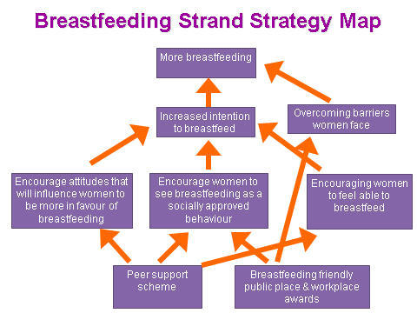

Figure 4: Using the TPB to understand increases in breastfeeding rates

There were two main benefits of the strategy map in figure 4. Firstly it helped the programme focus on each of the various areas which will influence behaviour. Secondly, it aided the evaluation by supplementing the data on breastfeeding maintenance rates by asking the women whether they were more positive about the idea of breastfeeding, whether they saw it as a socially approved behaviour, and whether they felt more confident about being able to breastfeed when the time came.

Another example of the usefulness of the approach was when evaluating a workshop on diet and exercise provided for workers at a Sheffield steel manufacturer. While feedback from participants was quite positive, one senior manager commented that the company did not have space for a canteen on site - but there was a convenient mobile burger bar parked outside the factory gates every lunchtime! Clearly, unless that particular barrier is overcome, one workshop was unlikely to lead to a significant change in obesity levels of workers or their families.

The strategy map for the Sheffield Let's Change4Life project as a whole is shown in Figure 5. This was developed following interactive workshops with the Programme Board, operational leads and stakeholders of the eight programme strands, and Sheffield Youth Council. The first two rows show the main outcomes required for the project. The main desired outcome was to reduce obesity, while other key outcomes which will contribute towards this overall outcome include better diet and nutrition and increased physical activity. Satisfied stakeholders, sustainability and value for money were also key aims.

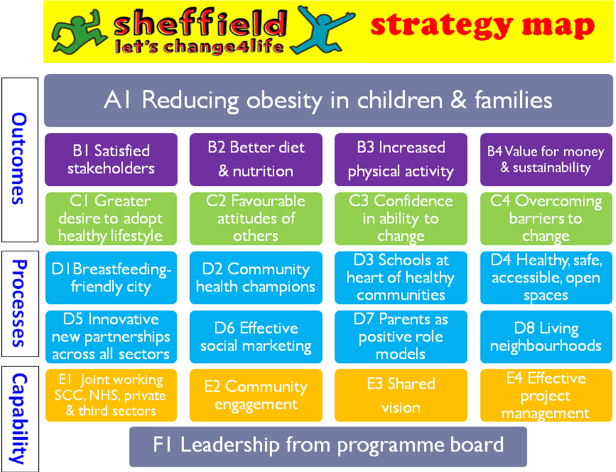

Figure 5. Strategy Map for Sheffield Let's Change4Life

The third row shows the Theory of Planned Behaviour outputs and outcomes in relation to changing people's behaviour - a greater desire to adopt a healthy lifestyle; favourable attitudes; confidence in their ability to change; and overcoming the barriers they face - while rows 4 and 5 refer to the desired outcomes and outputs of the eight strands of the programme. The penultimate row shows the main elements that need to be in place to support the individual strands in achieving the desired outcomes, all of which need to be underpinned by effective leadership and support from the programme board.

The strategy map was used both to help managers and strand leads focus on the desired outcomes, and to monitor and evaluate performance.

7. CONCLUSION

Performance management in the public and third sectors is understandably controversial. When done well it can motivate staff to improve performance and can ‘reveal the true performance of the system and the impact of any changes in real time’ (NHS Modernisation Agency, 2004). When done poorly, however, it can alienate employees and lead to a culture of blame where staff meet targets at the expense of service to the public (Moullin, 2009a).

The Public Sector Scorecard is an effective framework for helping public and third sector organisations monitor and improve their services and focus on delivering desired outcomes including value for money. The incorporation of process mapping, systems thinking and lean management approaches ensures that service improvement is considered in relation to the outcomes required including value for money. Furthermore it does not stop at processes - it addresses risk management, organisation culture and capability to ensure that staff and processes are supported in delivering the required outcomes.

Finally, by measuring performance on outcome, process and capability elements, the PSS enables managers and others to identify where the organisation is making progress. Described as ‘groundbreaking’ by a former head of research at the New York Senate (Penna, 2011), it is consistent with the recommendation in the Darzi report that 'NHS services… will need to develop their own quality frameworks combining relevant indicators defined nationally, with those appropriate to local circumstances' (Department of Health, 2008). Applications include central and local government and health services, mainly in the UK, but also in the Middle East and South Africa.

REFERENCES

- Ajzen, I. (1991) The Theory of Planned Behavior. Organizational Behavior and Human Decision Processes, 50(2), 179-211.
- Antony, J. (2006) Six Sigma for Service Processes, Business Process Management Journal, Vol.12, No.2,pp.234-238.
- Balanced Scorecard Collaborative (2004) Using the Balanced Scorecard to create value in the Electric Cooperative Community. Balanced Scorecard Collaborative, Lincoln MA, www.bscol.com.
- Bhatia, N. and Drew, J. (2006) Applying Lean Production to the Public Sector, The McKinsley Quarterly, June.
- Bourne, M. and Bourne, P. (2007) Balanced Scorecard. Chartered Management Institute, London
- Brooks, R. (Ed) (2007) Public Services at the Crossroads, Institute for Public Policy Research, London
- Care Quality Commission (2009) Annual Health Check 2008/9. Care Quality Commission, March 2009
- DCSF(2006) Youth Matters. Dept of Children, Schools and Families, HMSO, London
- Deming, W.E. (1993) The New Economics for Industry, Government and Education, MIT Press, Cambridge, Mass.
- Department of Health (2008) High Quality Care for All: NHS Next Stage Review final report, Dept of Health, London
- Gambles, I. (1999) A balanced future lies in the cards, Public Finance, 16-22 April: pp.24-5.
- Greatbanks, R. and Tapp, D. (2007) The impact of balanced scorecards in a public sector environment: empirical evidence from Dunedin City Council, New Zealand, International Journal of Operations & Production Management. Vol. 27, No. 8, pp.846-873.
- Gurd, B. and Gao, T. (2008) Lives in the balance: an analysis of the balanced scorecard (BSC) in healthcare organisations. International Journal of Productivity and Performance Management, Vol.57(1),pp.6-21.
- Irwin, D. (2002) Strategy mapping in the public sector. Long Range Planning, Vol. 35(6), pp.637-647.
- Johnston, R. and Pongatichat, P. (2008) Managing the tension between performance measurement and strategy: coping strategies. International Journal of Operations and Production Management, Vol.28, No.10,pp. 941-967.
- Kaplan, R.S. (2009) Risk Management and the Strategy Execution System. Balanced Scorecard Report, Nov–Dec 2009, Vol.11, No.6, Harvard Business School.
- Kaplan, R.S. and Norton, D.P. (2001a) The Strategy-Focused Organization, Harvard Business School Press, Boston, MA.
- Kaplan, R.S. and Norton, D.P. (2001b), “Transforming the balanced scorecard from performance measurement to strategic management: part 1”, Accounting Horizons, Vol. 15 No. 1, pp. 87-104.
- Lawrie, G. and Cobbold, I. (2004). How a public sector agency re-invigorated its Balanced Scorecard. 2GC Active Management, Maidenhead.
- McAdam, R., Hazlett, S. and Casey, C. (2005) Performance Management in the UK Public Sector: Addressing multiple stakeholder complexity. International Journal of Public Sector Management, Vol.18, No.3, pp.256-273
- Moullin, M. (2002) Delivering Excellence in Health and Social Care, Open University Press, Buckingham.
- Moullin, M. (2004) “Eight Essentials of Performance Measurement”. International Journal of Health Care Quality Assurance, Vol.17, No.3, March 2004. 17:3.
- Moullin, M. (2006) The design of an alternative Balanced Scorecard framework for public and voluntary organizations, Perspectives on Performance, Vol.5, Issue 1. Performance Measurement Association
- Moullin, M. (2009a) Using the Public Sector Scorecard to measure and improve healthcare services. Nursing Management, September 2009, Vol. 16, No.5, pp.26-31
- Moullin, M. (2009b) What's the score? Feature Article, Public Finance, 21 May, Chartered Institute of Public Finance and Accountancy, London.
- Moullin, M. (2009c) Lean and Six Sigma – Can they really be applied to the public sector? Public Sector Executive, May / June 2009.
- Moullin, M (2010) Careful targets can help to achieve goals. Local Government Chronicle, 11 February 2010.
- Moullin, M. and Copeland, R. (2012) Strategy Mapping with the Public Sector Scorecard - The Missing Link for Behaviour Change. Paper presented to the Performance Measurement Association Annual Conference, Cambridge 2012. Performance Measurement Association.
- Moullin, M and Copeland, R (2013) Implementing and evaluating behaviour change programmes with the Public Sector Scorecard. National Health Executive, Jul-Aug 2013, pp.16-18
- Moullin, M., Soady, J, Skinner, J., Price, C., Cullen, J. and Gilligan, C. (2007) Using the Public Sector Scorecard in Public Health. International Journal of Health Care Quality Assurance, Vol. 20, No. 4, pp.281-289
- NHS Modernisation Agency (2004)10 High Impact Changes for service improvement and delivery. NHS Modernisation Agency, Leicester
- Niven, P.R.(2003) Balanced scorecard step-by-step for government and non-profit agencies. John Wiley and Sons, Hoboken, NJ.
- Northcott, D and Taulapapa, TM (2012) Using the balanced scorecard to manage performance in public sector organizations: Issues and challenges International Journal of Public Sector Management, Vol. 25 Issue 3.
- Osborne, S.P. Radnor, Z. and Nasi, G. (2013) A New Theory for Public Service Management? Towards a (Public) Service Dominant Approach, The American Review of Public Administration, Vol.43, No.2, pp.135-158.
- Penna, B. (2011) The Nonprofit Outcomes Toolbox: A Complete Guide to Program Effectiveness, Performance Measurement, and Results. John Wiley and Sons, Hoboken, New Jersey.
- Pidd, M. (2012) Measuring the Performance of Public Services, Cambridge University Press, Cambridge.
- Radnor, Z. and Lovell, B. (2003) “Success factors for implementation of the Balanced Scorecard in a NHS multi-agency setting”, International Journal of Health Care Quality Assurance, Vol. 16 No.2.
- Radnor, Z and Osborne, SP (2013) Lean: A failed theory for public services?, Public Management Review, 15(2), pp.265-287, ISSN: 1471-9037
- Smith, P. (1993) Outcome-related performance indicators and organizational control in the public sector, British Journal of Management, Vol.4, No.3, pp. 135-151.
- Thornton, J. (2009) Public Sector Performance Management: A discussion draft to stimulate debate and feedback. Oracle Corporation.

