**MAY 2014 INSIDE O.R.**

**HOW ARE YOU DOING?  
JANE PARKIN**Max Moullin, Director of the Public Sector Scorecard Research Centre, ran an excellent interactive presentation to the Yorkshire and Humberside O.R. Group on the many pitfalls of managing and measuring performance and how to overcome them.

He introduced the session saying that O.R. and Analytics professionals had much to offer performance management in the public and third sectors, with both soft and hard O.R. approaches having an important role. He discussed both the Balanced Scorecard and the Public Sector Scorecard. He emphasised the importance of focussing on outcomes and evidence-based drivers of outcomes and of a performance management culture focussed on stakeholder engagement, improvement, accountability and change, rather than a top-down blame culture.

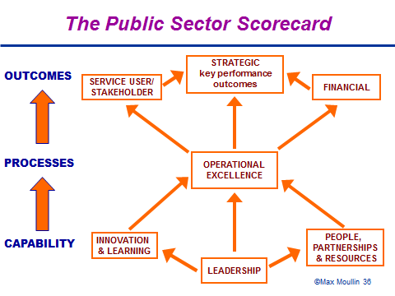

The participants enjoyed two group exercises. For the first, we examined performance measures in our own organisations and rated, on a scale of 1 to 5, the following aspects:

* Are they balanced?
* Do they measure what really matters to service users?
* Were staff involved in determining the measures?
* Is performance managed across organisational boundaries?
* Do they focus on outcomes and evidence-based drivers of outcomes?
* Do they take into account the cost of measurement?
* Are they based on a culture of continuous improvement rather than blame?

The majority of the organisations represented were able to provide positive responses to some of the questions: there was evidence in both the Department of Health and the Department of Work and Pensions that the cost of measurement was considered and measures amended to reduce costs. There was discussion about how to determine measures when work is contracted out; Max suggested that they should be agreed by both the contracting and the contracted organisations.

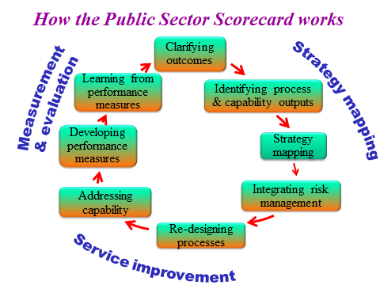

The second exercise involved designing a strategy map for one or two outcomes the group wished to consider:

* What are the main processes of activities that will affect these outcomes?
* What are the key success factors or outputs that the processes need to deliver to achieve these outcomes?
* What are the main organisational and capability factors that will influence whether the processes achieve the desired outputs and outcomes?

Max finished by summarising some problems with scorecards today and making the following recommendations:

* Focus on the outcomes that matter to users and other key stakeholders
* Consider how your processes can be more effective in delivering these outcomes
* Look at how your organisation can improve its capability in meeting these outcomes
* Develop performance measures around desired outcomes, processes and capability
* Develop a culture of innovation and continuous improvement and not a blame culture
* Develop performance measures and targets jointly with the organisations that are being held to account.
* Scrap any measures not directly related to outcomes or evidence-based drivers of outcomes
* If performance is below target, organisations/departments should be able to offer an explanation of any exceptional circumstances
* Public and third sector organisations need to develop their own integrated service improvement and performance measurement frameworks
* Use the Public Sector Scorecard to help you.

The group then adjourned to the Wardrobe for drinks and further discussion.

Max’s slides are available at www.publicsectorscorecard.co.uk.on the ORS website. For further information, contact Max at max@publicsectorscorecard.co.uk